Experiment 6: Subqueries

RA1911003010575

Dhawal Patil

CSE A2

1. Suppliers(sid:integer, sname:string, city:string, street:string)

Parts(pid:integer, pname:string, color:string)

Catalog(sid:integer, pid:integer, cost:real)

* **Write a query retrieves the name (sname) of suppliers, who have supplied a non-blue part.**

**Query - SELECT S.sname FROM Suppliers S WHERE S.sid NOT IN (SELECT C.sid FROM Catalog C WHERE C.pid NOT IN (SELECT P.pid FROM Parts P WHERE P.color<> 'blue'));**

1. Consider the following relations:

|  |  |  |  |  |  |  |  |  |  |  |  |  |  |  |  |  |  |  |  |  |  |  |  |  |  |  |  |  |  |  |  |  |  |  |  |
| --- | --- | --- | --- | --- | --- | --- | --- | --- | --- | --- | --- | --- | --- | --- | --- | --- | --- | --- | --- | --- | --- | --- | --- | --- | --- | --- | --- | --- | --- | --- | --- | --- | --- | --- | --- |
| |  |  | | --- | --- | | Student | | | Roll_No | Student_Name | | 1 | Raj | | 2 | Rohit | | 3 | Raj | | |  |  |  | | --- | --- | --- | | Performance | | | | Roll_No | Course | Marks | | 1 | Math | 80 | | 1 | English | 70 | | 2 | Math | 75 | | 3 | English | 80 | | 2 | Physics | 65 | | 3 | Math | 80 | |

* **Write a query to find the sum of marks for each student.**

**Query - select P.Roll_No, sum(P.Marks) as Total_Marks from student s, Performance P where s.Roll_No=P.Roll_No group by P.Roll_No;**

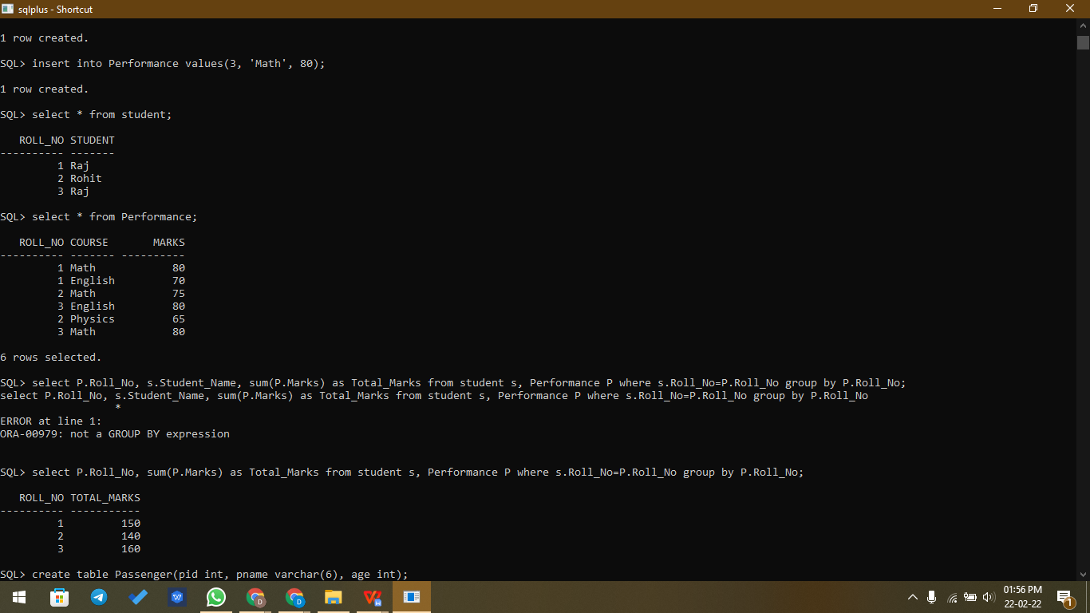

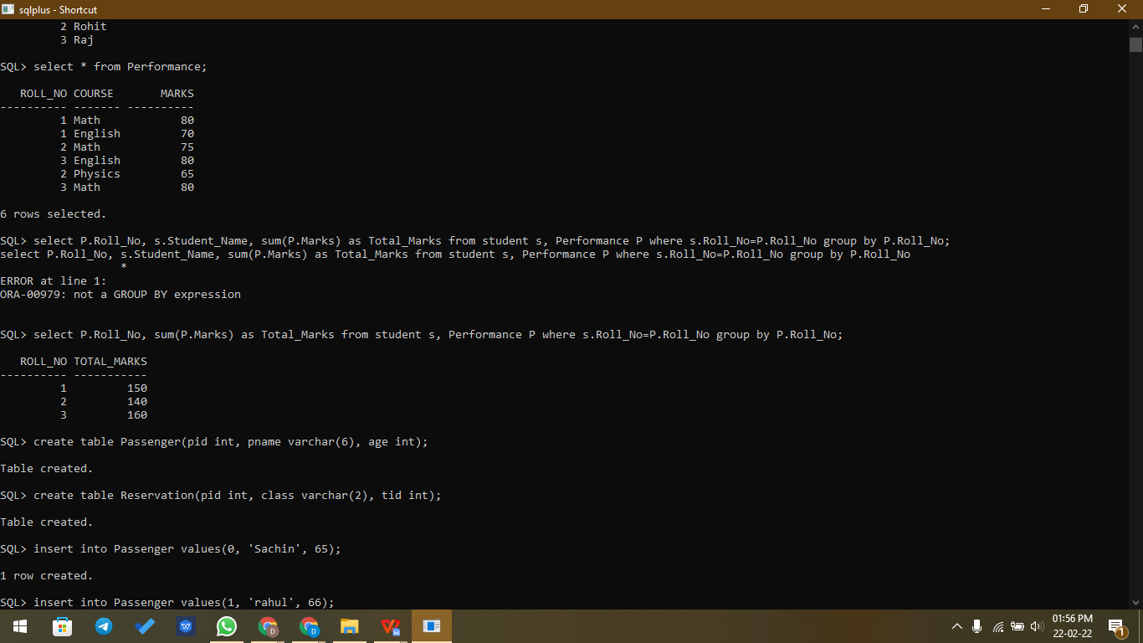

1. Passenger (pid, pname, age)  
   Reservation (pid, class, tid)

|  |  |  |  |  |  |  |  |  |  |  |  |  |  |  |  |  |  |  |  |  |  |  |  |  |  |  |  |  |  |  |  |  |  |  |  |  |  |
| --- | --- | --- | --- | --- | --- | --- | --- | --- | --- | --- | --- | --- | --- | --- | --- | --- | --- | --- | --- | --- | --- | --- | --- | --- | --- | --- | --- | --- | --- | --- | --- | --- | --- | --- | --- | --- | --- |
| **Table: Passenger**   |  |  |  | | --- | --- | --- | | pid | pname | age | | 0 | Sachin | 65 | | 1 | Rahul | 66 | | 2 | Sourav | 67 | | 3 | Anil | 69 | | **Table : Reservation**   |  |  |  | | --- | --- | --- | | pid | class | tid | | 0 | AC | 8200 | | 1 | AC | 8201 | | 2 | SC | 8201 | | 5 | AC | 8203 | | 1 | SC | 8204 | | 3 | AC | 8202 | |

* **Write a query to find the passengers who have done registration and also who have age greater than 65 who are travelling in “AC” class.**

Query - select distinct(P.pname) from Passenger P, Reservation R where P.age>65 and R.class='AC' and P.pid=R.pid;

